Holy Habits: Serving – week 4
In our last house group meeting two weeks ago, we studied Luke 10 v25-37, the Parable of the Good Samaritan. This is a very familiar passage to me, which I’ve heard many times from Sunday school days, and many times in Church. I must be honest, I did wonder if there was anything new to be said! How wrong can you be!
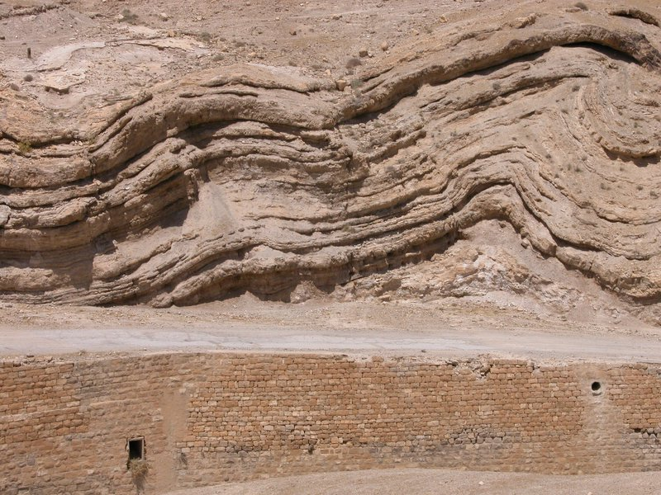

Image of the Old Road from Jerusalem to Jericho (accessed 18/07/2020 via Wikipedia). Permission details: original uploader was [1]

After reading the parable and following a short discussion, thanks to the wonders of “zoom” our meeting abruptly finished after 40 minutes. This was a pity, as I felt there was a lot more to explore, and we had only just got going! We were encouraged to reflect on the passage, so consequently, I’d like to share my thoughts with you about the people in the parable and their possible motives, and link this to the Holy Habit of serving.
The first person mentioned in the parable was “an expert in the law.” I’m making assumptions that he was probably a Pharisee, and I’m guessing that because he was described as an expert, he was not young! Pharisees emphasised the oral tradition of retelling the Torah (The first 5 books of our Old Testament in the Bible), which they believed was handed down directly from God to Moses (overviewbible.com/Pharisees/ accessed 18/7/2020), and were committed to instructing Jews how to obey their interpretation of the 613 laws and rituals contained in the Torah in minute detail (Life Application Study Bible, 2005). This oral tradition became very important to the Jewish people during times of captivity. It is thought that contemporaries of the Pharisees wrote down these oral accounts, and were the authors of the Dead Sea Scrolls (overviewbible.com/Pharisees/ accessed 18/7/2020), so we have got the Pharisees to thank in part for the Old Testament!
Because the Pharisee was an expert in the law, he probably knew the answer to the first question he asked (Luke 10 v27-28). Maybe he wanted to show Jesus how knowledgeable he was, which is why he asked a question that he knew the answer to. Jesus affirmed his knowledge (v28). However, Jesus was publically scathing about the hypocritical behaviour of Pharisees (see Matthew chapter 23), so it is not surprising that this particular Pharisee’s motivation was to test Jesus (Luke 10 v25), and perhaps catch him out as maybe he thought Jesus would be unable to answer his second question.
What strikes me is that Jesus didn’t answer in a straightforward way, but in a parable. Parables are stories that have hidden spiritual meanings. In Bible times, the notorious Jerusalem to Jericho road was known as the “way of blood” due to the blood shed by attacking robbers, and was a 25 kilometre winding, meandering and steep road beginning 1,200 feet above sea level, and finishing 2,200 feet below sea level (https://en.wikipedia.org/wiki/Parable_of_the_Good_Samaritan, accessed 18/07/2020). Presumably the man travelling along this road was a Jew, and knew of its dangers, but was prepared to take risks to get to his destination. He was severely attacked, stripped of his clothes and left for dead (v30).
After noticing the man who was naked and left for dead, the priest passed by on the other side of the road. Why did he do this? Was it because he felt it was beneath his dignity to help the man?? If a priest touched, or held his hand over a dead or dying person, strict Jewish laws would deem the priest ritually impure and potentially the Temple where he served would become unclean (https://www.bibleodyssey.org:443/en/passages/related-articles/priests-and-levites-in-the-first-century-ce accessed 22/7/20) (Numbers 19 v 11-13). Perhaps the priest believed that by crossing the road, he was serving God and his fellow Jews, because by keeping himself clean he would not contaminate the Temple
The Levite also crossed the road. Was it because he didn’t have the time or inclination to help? Levites served in the Temple as musicians, gate keepers, guardians, temple officials, judges and craftsmen (www.britannica.com accessed 22/7/20), so maybe if the Levite had touched the dead or dying person, he wouldn’t have been able to serve God or the Jewish people in the Temple.
We don’t know why the Samaritan man was travelling on the road, but we do know that he was probably a long way from home, since the distance between Samaria and Jerusalem is 692 miles as the crow flies (www.distancebetween2.com accessed25/7/20). Samaritans were descended from Jews who survived the exile of Israel in 722 BC and intermarried with local Assyrian people (www.wikipedia.org accessed 25/7/20). Consequently, their descendants were a mixed race of people who were half Jewish and half Gentiles, and were known as Samaritans (https://www.blueletterbible.org/faq/don_stewart/don_stewart_1319.cfm accessed 25/7/20). Subsequently, a deep hatred existed between Jews and the Samaritans (Life Application Study Bible, 2005).
It’s even more surprising then, that the Samaritan took pity on the Jewish man, physically attended to his medical needs, then put him on his donkey and cared for him in an inn (v33-34). The two silver coins were minted in Rome, Alexandria and Antioch, and academics believe it was enough money to pay for the man to be cared for at the inn between two weeks and two months (https://bibleresources.americanbible.org/resource/the-good-samaritan-039-s-money accessed 25/7/20). That’s quite a lot of money to spend on someone who came from a culture whose people had been your sworn enemy for centuries!
When the Pharisee asked Jesus “who is my neighbour,” I wonder if he expected Jesus to reply “Mr and Mrs such and such are your neighbours?” or “the people in your local Jewish community?” I bet he didn’t expect Jesus to tell a story about people who showed, or didn’t show the neighbourly characteristic of serving, towards someone who was deemed to be their enemy. I bet he didn’t expect to be challenged to “go and do likewise! (v37)”
Linking this to the Holy Habit of Serving, when we ask God in prayer for guidance about what we should do in a situation, or how we could serve others in the Church or in the community, are we expecting him to affirm our own thoughts and ideas? Or should we be open to the prompting of the Holy Spirit who might surprise us about the ways he wants us to serve, which we had not imagined or thought of?
As I mentioned in the beginning, I thought I was familiar with the parable of the Good Samaritan. This study reminded me that it’s good to read old familiar passages in the Bible and to ask God to help me reflect on the passage and to be open to what he has to teach me. You never know what insights you will discover!

Produced by Debs Barnett on behalf of the Bents Green Holy Habits Planning Group (Debs Barnett, Glenn Evans, Martyn Read, Graham Wassell, Daphne and John Wilkins). You can find more information on the Circuit Holy Habits Programme on the Sheffield Methodist Circuit website and also the Sheffield Methodist Circuit Facebook page.

