Love & Grace
When was the last time that you did some colouring in? You may not be able to remember. You may have done some with a child or a grandchild. You may have applied yourself to some for your own benefit – because these days it is acknowledged that it can be a means of self-care, reducing, for example, stress and anxiety. The reason for this lies in the fact that it is a repetitive activity which requires attention to detail. When you are focused on the colouring, your attention is taken away from yourself and the things that are stressing you out or making you feel anxious. When someone is colouring in, the aim is to keep within the lines. However, there is the possibility that the crayoning goes outside the defined sections. So, the end result is not as exact as it could be.
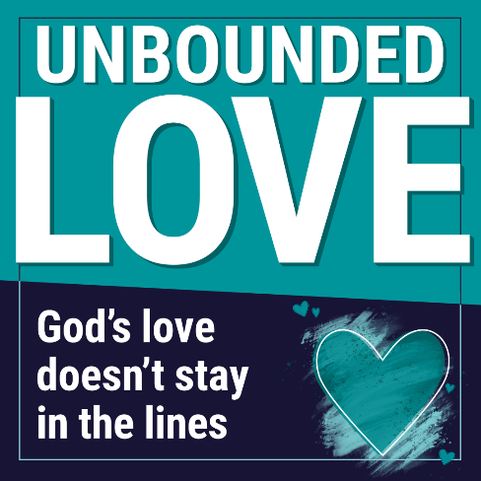
This year during Lent, the Methodist Church has been running a campaign with the title Unbounded Love and the strap-line God's love doesn't stay in the lines. The phrase ‘unbounded love’ comes from Charles Wesley's well-known hymn Love Divine, All Loves Excelling. It talks about Jesus as ‘unbounded love’ – love that cannot be restricted, which is at work in our lives and in our world to set us free and overcome all that is harmful and not good. The image for the campaign, which is shown, has, alongside the words ‘God’s love doesn’t stay in the lines’, a heart which is crayoned in, with the colour also crayoned beyond the boundaries of that heart.
This idea of love which doesn’t stay in the lines, perhaps sits well with the Methodist logo of the Orb and Cross, which is also shown. On the Methodist Church’s national website, the symbolism is explained as follows: ‘The Orb represents the world. The colour red, the traditional colour of Pentecost, may be taken to symbolise the Methodist conviction that through the power of the Holy Spirit, all humanity may be saved. The Orb is charged with a radiant Cross, which, like the field it is set on, is white, celebrating the glory of the risen Saviour. There is no boundary to the arms of the cross, just as there are no limits to the grace of God.’ So, the Orb and Cross represent limitless grace which also cannot be confined.
In their song, In Christ Alone, Stuart Townend and Keith Getty write: ‘Then bursting forth, in glorious day, up from the grave [Christ] rose again!’ The grave could not hold Christ in. His unbounded love and limitless grace burst forth on Easter Day. God’s love and grace don’t stay in the lines. They can burst forth anywhere, at any time and for anyone. Have you experienced God’s love and grace: love which is unconditional; grace which gives you what you do not deserve? If so, give thanks to God. If not, why not open your heart to God to receive these gifts and see what difference they make in your life?
When was the last time you did some colouring in? I think, for me, it was 22nd December 2023. I was very careful to keep within the lines then. Maybe next time I will be less concerned to do so. Then I may be able to reflect more on the unbounded love of Jesus and the limitless grace of God.
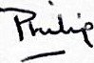
May you know God’s love and grace at work in your life.

