**A Harvest of Hope**

This harvest-time, Christian Aid are putting a spotlight on West Africa and are introducing us to one of the farmers who lives there.

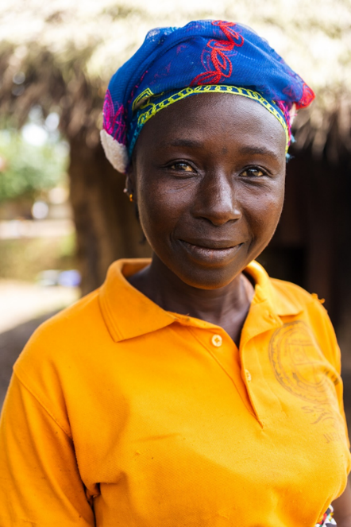This is Maryama, a widowed mother of four children, aged 18, 12, 9 and 6 and they live in Sierra Leone. Maryama, like lots of people there, grows her own food and sells some of it so that she has money to buy other things. However, Maryama and other farmers in Sierra Leone have been struggling. Climate change means that the weather is less predictable. It can be extremely hot and there are more storms than there were in the past. This makes it difficult to grow plants for food. It is also hard for women like Maryama to invest in their farms. They need money to buy seeds and tools but they do not always have enough money to pay for them when they need them. Maryama found herself taking out loans that were unsustainable for her. As she told Christian Aid, ‘... there was a lot of challenges ... Repaying loans has been a serious problem.’

However, there is hope. Farmers in Sierra Leone have created their own groups called ‘Village Savings and Loan Associations’, which partners of Christian Aid have helped them set up. These groups help them to work together to save, borrow and spend money on farming in such a way that they have food for their families and crops they can sell.

Maryama told Christian Aid, ‘Women should have power and they should be able to take decisions.’

Whilst Maryama does not have to pay school fees for her children, there are costs associated with their education: uniforms, transport and books can be very expensive. However, Maryama is now able to pay for these from the crops she sells. She knows that her children will learn from their schooling, giving them more choices about what they can do in the future.

Revd Philip Peacock based on Christian Aid Harvest resources for 2025.

If you want to support Christian Aid’s Harvest of Hope Appeal financially, please go to: <https://give.christianaid.org.uk/donate/CAM-009516>. Your gift will mean that farming families like Maryama’s can secure their harvests and strengthen their hope in the face of climate shocks. Or it could provide the training farmers need to adapt to the changing climate, so that they can enjoy a bountiful harvest and provide for their families.